Find the

* Percentage
* Fraction
* Decimal

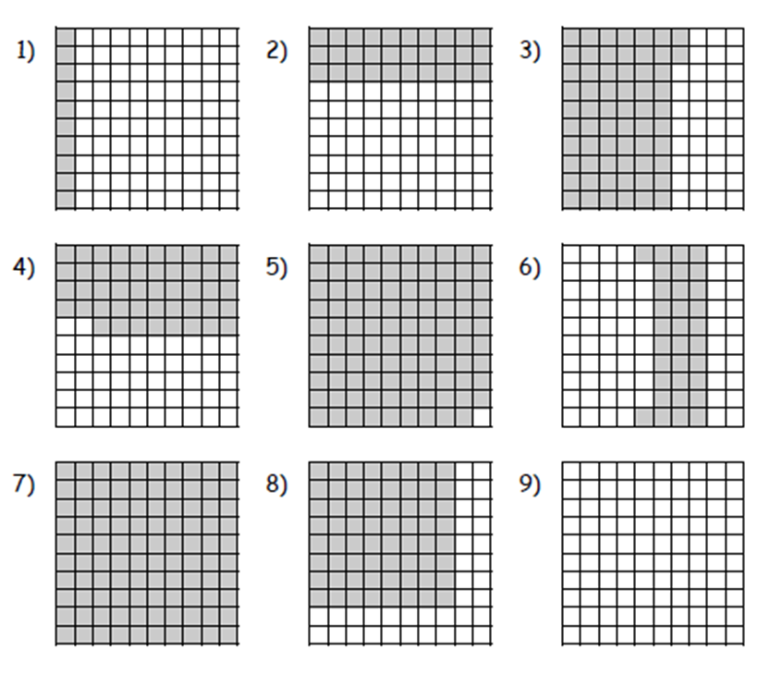of the shaded and white area.

Set it out like this in your book:

1. Percentage: shaded- 10%, white- 90%

Fraction: shaded- 1/10, white- 9/10

Decimal: shaded- 0.1, white- 0.9

Then have a go at these questions:

7) 50% of the class were girls. What percentage were boys?

8) Annie ate 10% of a cake, Jake ate 30%, how much was left?

9) A paper is 20cm long. I cut it into two. One piece is 13.5cm. How long is the other piece?

10) Sarah and Tom share a chocolate. Sarah has 4/10, how much does Tom have?